Quiz Score Totals
Code:
from airflow import DAG # type: ignore
from airflow.providers.standard.operators.python import PythonOperator # type: ignore
from datetime import datetime

def maths_score(**kwargs):
ti = kwargs['ti']
ti.xcom_push(key="maths", value=78)
print("Maths score pushed: 78")

def english_score(**kwargs):
ti = kwargs['ti']
ti.xcom_push(key="english", value=85)
print("English score pushed: 85")

def science_score(**kwargs):
ti = kwargs['ti']
ti.xcom_push(key="science", value=62)
print("Science score pushed: 62")

def calculate_average(**kwargs):
ti = kwargs['ti']
maths = ti.xcom_pull(key="maths", task_ids="maths_score")
english = ti.xcom_pull(key="english", task_ids="english_score")
science = ti.xcom_pull(key="science", task_ids="science_score")

average = (maths + english + science) / 3
if average >= 90:
grade = "A"
elif average >= 75:
grade = "B"
elif average >= 60:
grade = "C"
else:
grade = "D"
print(
f"""
Maths: {maths}\nEnglish: {english}\nScience: {science}\nAverage: {average}\nGrade: {grade}
""",flush=True
)
return {"average": average, "grade": grade}

def print_report(**kwargs):
ti = kwargs['ti']

maths = ti.xcom_pull(task_ids="maths_score", key="maths")
english = ti.xcom_pull(task_ids="english_score", key="english")
science = ti.xcom_pull(task_ids="science_score", key="science")

result = ti.xcom_pull(task_ids="calculate_average")

print(
f"""
----- QUIZ REPORT -----
Maths: {maths}\nEnglish: {english}\nScience: {science}\nAverage: {result['average']}\nGrade: {result['grade']}
------------------------
""",flush=True)
with DAG(
dag_id="quiz_scores",
schedule="@once",
start_date=datetime(2024, 1, 1),
catchup=False
) as dag:
maths_score = PythonOperator(
task_id="maths_score",
python_callable=maths_score
)

english_score = PythonOperator(
task_id="english_score",
python_callable=english_score
)

science_score = PythonOperator(
task_id="science_score",
python_callable=science_score
)

calculate_average = PythonOperator(
task_id="calculate_average",
python_callable=calculate_average,
trigger_rule="all_done"
)

print_report = PythonOperator(
task_id="print_report",
python_callable=print_report,
trigger_rule="all_done"
)
[maths_score, english_score, science_score] >> calculate_average >> print_report # type: ignore

- Graph View — all 5 tasks GREEN, 3 score tasks at same level then calculate then report
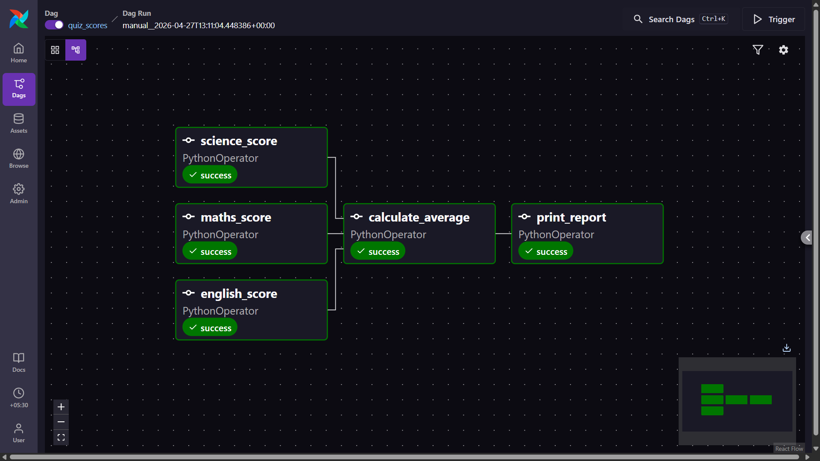
- Admin → XComs page — showing the 3 named XCom entries (maths, english, science keys visible)
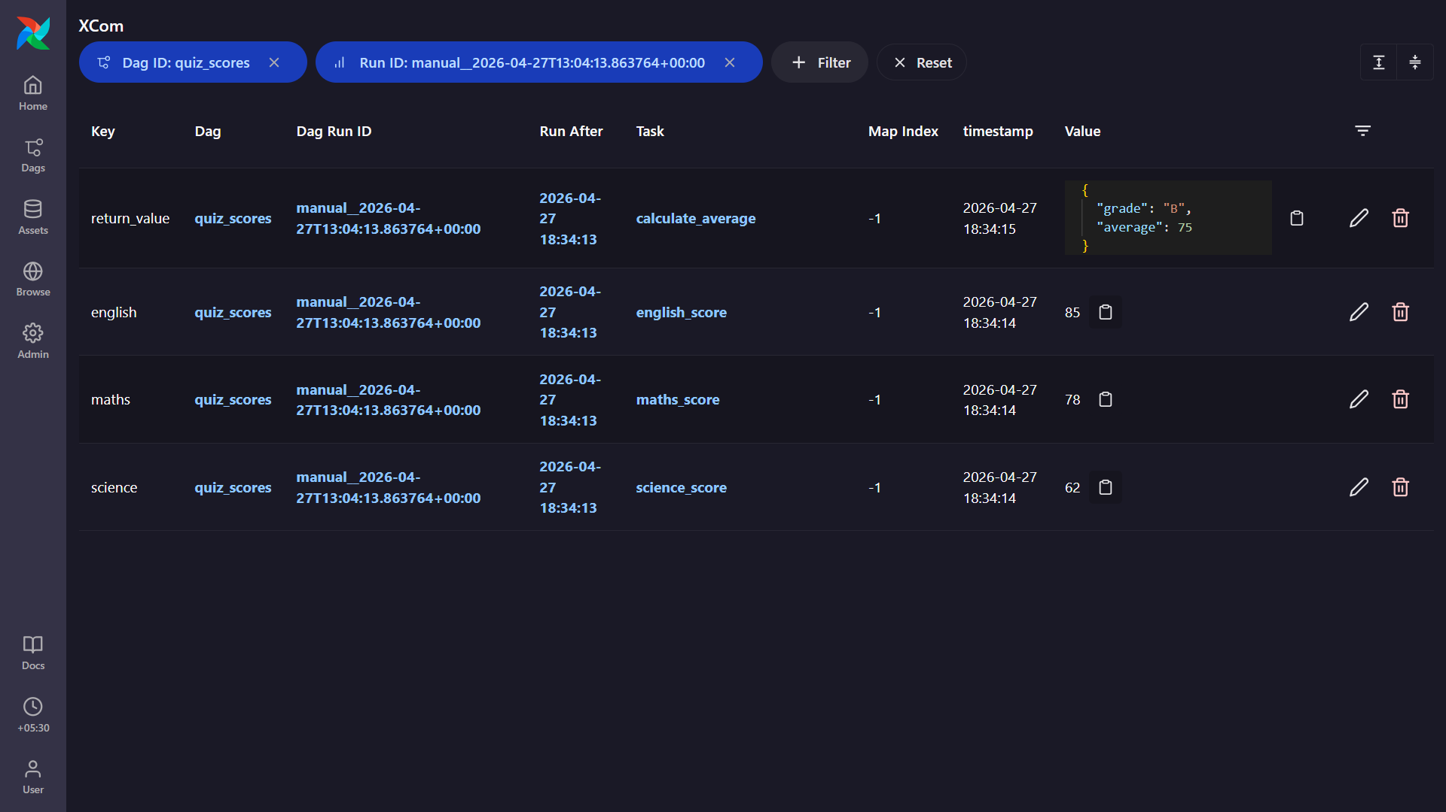
- Task Log of calculate_average — showing all 3 pulled scores, the average, and the grade
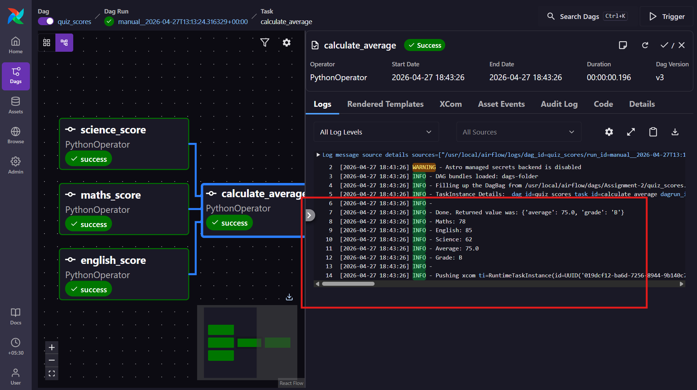

- Task Log of print_report — showing the full formatted report
